## Baccalaureate Themes:

## Building and Expressing Yourself and/or Travels, Territory and Borders

### Key question: To what extent does chaos lead to rebuilding oneself?

# Requirements:

At least 2 literary documents:

* Still I Rise – Maya Angelou 1978
* I Know This Much Is True – Wally Lamb 1998

No more than 2 visual documents

* The Joker – Todd Phillips 2019
* Red Sparrow – Francis Lawrence 2018

At least 1 document from the program

* The Handmaid’s Tale – Margaret Atwood 1985

At least 1 non-literary document

* The Lost Café Schindler: One Family, Two Wars, and the Search for Truth (English Edition) 2020-2021

# The Lost Cafe Schindler

#### Meriel Schindler

Hörhager picks up Kurt’s toboggan, which is propped up against a wall in the hall. He holds the woven seat and lifts it high above his head, then brings it down hard on Hugo’s head. One of the iron strips that is nailed to the hooped runners to protect the wood, cuts a deep vertical gash down Hugo's forehead, and blood drips down his face and into his eyes. […]

In all, the whole episode lasts no more than twenty minutes. As they leave, one of the men shouts at Hugo: ‘You had no mercy on us, when we were unemployed for years!’ […]

When the men left Hugo, the group split up. Three went home, and Hörhager, Schneider and Ebner walk to the railway station bar to report to Squadron Leader Mayerbrucker, who is waiting for them. Ebner describes carefully what they have done, noting by name who has been cooperative and who has been less helpful. […]

Back at the flat, Sofie Freiger is trying to wake up Dr Biendl, who lives on the third floor. He is out at his mother’s house but returned a short while later.

According to his witness statement, Dr Biendl entered the Schindler flat and found the bedroom in chaos. Furniture was broken and there were splashes of blood everywhere. Biendl describes how shocked he was at Hugo’s state. He has a 10 cm gash on his head that was bleeding heavily and was deep enough to reveal his skull. His arm and leg were also injured. Just as Dr Biendl is bandaging Hugo up, three members of the Gestapo arrive in the flat. Upon seeing the doctor, they scream at him, ‘What are you doing here?!’

Dr Biendl responded, ‘As a doctor, I am obliged to provide medical help.’

The Gestapo then apparently looked around the room, note the broken furniture and, seemingly satisfied, left a few minutes later. In his statement, Dr Biendl describes Hugo as being utterly deranged. Hugo was very lucky indeed to have the doctor as a neighbour, not only because of the medical treatment he received but also because the Gestapo might otherwise have arrested him and taken him into 'protective custody', as they did many other Jews that evening.

After the Gestapo leave, Dr Biendl moves Hugo to a local sanatorium, where he stitches up the wound himself under local anaesthetic. He decides against getting Hugo X-rayed as that would mean a trip to the X-ray room and others would then know he is in the sanatorium. Instead he uses cold compresses to bring down the swelling. In his witness statement, he does not recall any fractures and only remembers using bandages to treat Hugo.

Four days later Hugo leaves the sanatorium. He has no time to convalesce as he is determined to get himself and the rest of his family out of Austria. Sofie, who at eighty-one is still a formidable force, has no desire to leave Innsbruck, but even she can see that the Tyrol is no longer tenable.

The decision is made for them. In December 1938, Sofie, Hugo and Erich are ordered to move to Vienna as part of Hofer’s last sweep of the Jews in western Austria. As far as I can reconstruct, Erich escaped the violence of Innsbruck's pogrom as he was in a clinic in Germany for his heart condition.

# The Joker

#### Todd Phillips

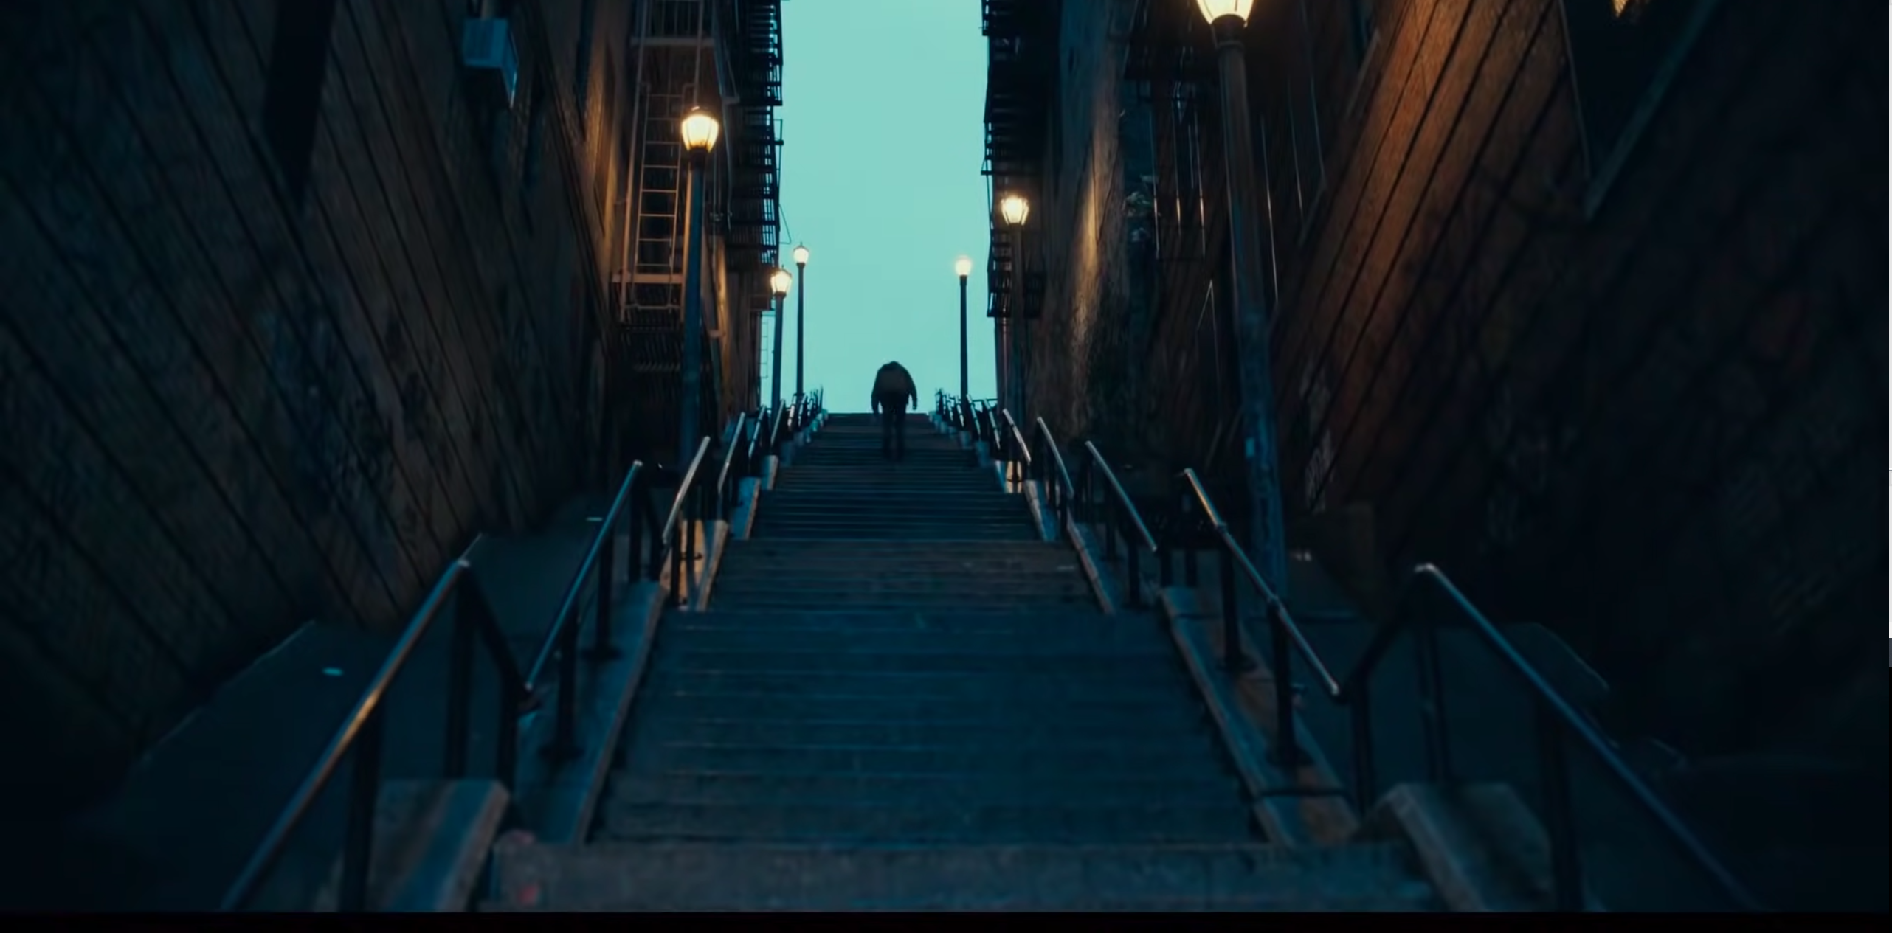

Arthur Fleck climbing the stairs

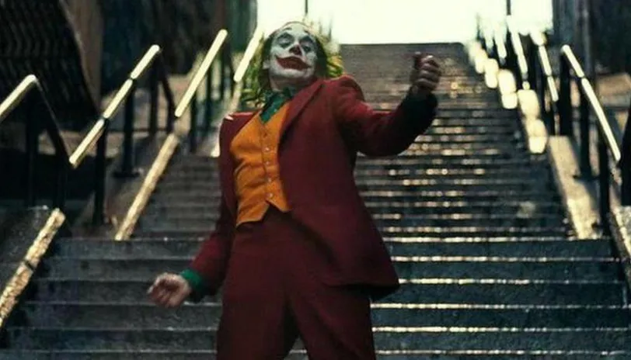

The Joker walking down the stairs

# The Handmaid’s Tale (The escape)

#### Margaret Atwood

We have almost nothing with us, we don't want to look as if we're going anywhere far or permanent. We have the forged passports, guaranteed, worth the price. We couldn't pay in money, of course, or put it on the Compucount: we used other things, some jewellery that was my grandmother's, a stamp collection Luke inherited from his uncle. Such things can be exchanged, for money, in other countries. When we get to the border, we'll pretend we're just going over on a day trip; the fake visas are for a day. Before that I'll give her [their daughter] a sleeping pill so she'll be asleep when we cross. That way she won't betray us. You can't expect a child to lie convincingly. And I don't want her to feel frightened, to feel the fear that is now tightening my muscles, tensing my spine, pulling me so taut that I'm certain I would break if touched. Every stoplight is an ordeal. We'll spend the night at a motel, or, better, sleeping in the car on a side road so there will be no suspicious questions. We'll cross in the morning, drive over the bridge, easily, just like driving to the supermarket. We turn onto the freeway, head north, flowing with not much traffic. Since the war started, gas is expensive and in short supply. Outside the city we pass the first checkpoint. All they want is a look at the license, Luke does it well. The license matches the passport: we thought of that. Back on the road, he squeezes my hand, glances over at me. You're white as a sheet, he says. That is how I feel: white, flat, thin. I feel transparent. Surely, they will be able to see through me. Worse, how will 1 be able to hold on to Luke, to her, when I'm so flat, so while? I feel as if there's not much left of me; they will slip through my arms, as if I'm made of smoke, as if I'm a mirage, fading before their eyes. […]Here is what I believe.

I believe Luke is lying face down in a thicket, a tangle of bracken, the brown fronds from last year under the green ones just unrolled, or ground hemlock perhaps, although it's too early for the red berries. What is left of him: his hair, the bones, the plaid wool shirt, green and black, the leather belt, the work boots. I know exactly what he was wearing. I can see his clothes in my mind, bright as a lithograph or a full-color advertisement, from an ancient magazine, though not his face, not so well. His face is beginning to fade, possibly because it wasn't always the same: his face had different expressions, his clothes did not. I pray that the hole, or two or three, there was more than one shot, they were close together, I pray that at least one hole is neatly, quickly, and finally through the skull, through the place where all the pictures were, so that there would have been only the one flash, of darkness or pain, dull I hope, like the word thud, only the one and then silence.

(p73-89)

# Red Sparrow

#### Francis Lawrence

|  |  |  |  |
| --- | --- | --- | --- |
| 1 | Afficher l’image source |  | 2 |
| 3 | Afficher l’image source |  | 4 |

# I Know This Much Is True

#### Wally Lamb

Ours was a terrible twenty-four-day journey to la ‘Merica, made unbearable by spoiled food, tainted water, and rolling seas. A broken propeller delayed us off the coast of Portugal for three extra days and nights of hell. Worst of all was the darkness and stink of life below, inside the belly of the big ship. Where there is sun and fresh air, there is hope, but here the sun did not shine and the air we breathed was stale and fetid. Aboveboard, bands played and the filthy rich dined off china and drank from fancy glasses. We in steerage lived like rats. Women and children sobbed, men fought each other over trifles, and everyone suffered the stench of vomit and excrement. There was a stabbing en route, and the birth of a baby, and the death of the child’s mother two days later. That crying bambino was passed from breast to breast after that, and we prayed for its fate. All our fates. That baby cried for us all! There were rats, too, plenty of them; night time was when those goddamned creatures prowled. One night I woke to find one sitting on my neck, sniffing at my mustache. I screamed out, waking even my brother Pasquale, who always slept like a dead man. After that night, I took no chances, napping as best I could while sitting or leaning against beams and walls. Day and night fell together on that hellish journey across the sea, and my mind existed in a place between sleep and vigilance.

# Still I Rise

#### Maya Angelou

You may write me down in history

With your bitter, twisted lies,

You may trod me in the very dirt

But still, like dust, I'll rise.

Does my sassiness upset you?

Why are you beset with gloom?

’Cause I walk like I've got oil wells

Pumping in my living room.

Just like moons and like suns,

With the certainty of tides,

Just like hopes springing high,

Still I'll rise.

Did you want to see me broken?

Bowed head and lowered eyes?

Shoulders falling down like teardrops,

Weakened by my soulful cries?

Does my haughtiness offend you?

Don't you take it awful hard

’Cause I laugh like I've got gold mines

Diggin’ in my own backyard.

You may shoot me with your words,

You may cut me with your eyes,

You may kill me with your hatefulness,

But still, like air, I’ll rise.

Does my sexiness upset you?

Does it come as a surprise

That I dance like I've got diamonds

At the meeting of my thighs?

Out of the huts of history’s shame

I rise

Up from a past that’s rooted in pain

I rise

I'm a black ocean, leaping and wide,

Welling and swelling I bear in the tide.

Leaving behind nights of terror and fear

I rise

Into a daybreak that’s wondrously clear

I rise

Bringing the gifts that my ancestors gave,

I am the dream and the hope of the slave.

I rise

I rise

I rise.